


Connector Functionality
Spotter Global Radar [VERSION]
Last update date: 25 Mar 2025

CONNECTOR DETAILS
Manufacturer | Spotter Global
Product name | Radar
Product category | Other
Connector Package Name | Evbg.CC.Driver.SpotterGlobal.Radar.Version.[FULLVERSION].ipscdriver
Connector version | [VERSION]
Supported Hardware
SDK/API version
Supported Control Center Version | 5.x
Tested against | [Control Center version range]
License Type | Other

www.everbridge.com

Contents
1 Document Versions 4
2 Manufacturer Details 4
3 Control Center Versions 4
4 Operating Systems 4
4.1 Client-Side Functionality 4
4.2 Server-Side Functionality 4
5 Subsystem 5
5.1.1 Radar System Details 5
6 Functionality 5
6.1 Integration Diagram 5
6.2 Connector Features 5
6.3 Radar Server 6
6.3.1 Properties 6
6.3.2 Methods 7
6.3.3 Events 8
6.3.4 Interfaces 8
6.4 Radar Device 8
6.4.1 Properties 8
6.4.2 Methods 9
6.4.3 Events 9
6.4.4 Interfaces 11
6.4.5 Custom States 11
6.5 Zone Device 11
6.5.1 Properties 11
6.5.2 Events 12
6.5.3 Interfaces 13
6.6 UDC Device 14
6.6.1 Properties 14
6.6.2 Events 14
6.6.3 Interfaces 15
6.7 Camera Device 15
6.7.1 Properties 15
6.7.2 Events 16
6.7.3 Interfaces 17
7 Compact Surveillance Radars 17
7.1 CK Series 17

Document Versions
Version | Date | Name | Change
1.0 | 25 Mar 2025 | Randika Madumal | Document Created.

Manufacturer Details
Name | Spotter Global
Logo | 
Website | https://www.spotterglobal.com/
Description | Spotter Global, founded in 2009, develops Compact Surveillance Radar for military and commercial security. Based in Orem, Utah, it ensures high-quality, U.S.-made products with a global reach.

Control Center Versions
The connector is compatible with the following Control Center versions:
Control Center Version | Supported | Tested against
5.x

Operating Systems

Client-Side Functionality
Operating Systems | Supported | Tested against
Windows 10 64 bit

Server-Side Functionality
Operating Systems | Supported | Tested against
Windows Server 2019

Subsystem
Subsystem | Version | Supported | Tested against

Radar System Details
Name | Radar System
Description | The GK and GX series radars use an Active Power over Ethernet connection, making installation easier and more cost effective while maintaining high performance when tracking.
Reference documents

Functionality

Integration Diagram
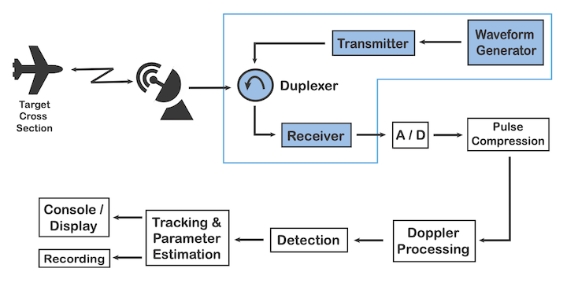

Connector Features
Feature | Value
Device Online Status | None
Authentication | None

Web Client Support

Radar Server

Properties
Name | Type | Description | Default Value & Ranges
Keep Alive Interval | int | Time interval in seconds between web service connectivity checks. | Default: 10  Min: 0  Max: None
Device Population Batch Size | int | Maximum devices allowed to populate at a time. | Default: 50  Min: 20  Max: 100
Log Level | LogLevel | Logging level of the driver. | Default: None  Min: None  Max: None
ListnerPort | int | Example Property for Server | Default: 6588  Min: None  Max: None
Simulation Mode | bool | When true, the connector simulates the subsystem instead of connecting to a real one. | Default: None  Min: None  Max: None
Polling Interval | int | Time interval in miliseconds between web service connectivity checks. | Default: 1000  Min: 0  Max: None
Timeout (INetworkedDevice) | TimeSpan | The timeout period to use when connecting to the physical device. Specify a zero period of time (00:00:00) to never timeout. | Default: 00:01:00  Min: None  Max: None
Retry Interval (INetworkedDevice) | TimeSpan | The amount of time to wait before attempting reconnection to a device after the connection has timed out or failed. Specify a zero period of time (00:00:00) to attempt reconnection instantly after a connection failure. | Default: 00:01:00  Min: None  Max: None
IP (INetworkedDevice) | String | The IP address for the device. | Default: None  Min: None  Max: None
Port (INetworkedDevice) | Int32 | The port the device listens on. | Default: None  Min: None  Max: None

Methods

Refresh Devices
Description | Refresh the devices to match the current configuration on Generic server.
Returns | bool
Operator Action | False
Parameters
Name | Type | Description | Default Value and Ranges
Refresh Properties | bool | Synchronise device properties and labels. | Default: None  Min: None  Max: None

Sample Server Method
Description | Sample Server Method
Returns | void
Operator Action | False

Events

Server Event
Description | Generic Server Event
Properties
Name | Type | Description
Sample Property | string | Sample Property
Description (Geospatial Aware Event) | string | Event description.

Interfaces
Name | Description
INetworkedDevice | The interface for all devices that connect to a physical device on the network.

Radar Device

Properties
Name | Type | Description | Default Value & Ranges
ID | string | Unique identifier. | Default: None  Min: None  Max: None
Parent ID | string | The parent device ID | Default: None  Min: None  Max: None
DeviceName | string | Device Name | Default: ""  Min: None  Max: None
Spatial Reference Identifier (IGeoSpatialAware) | Int32 | Spatial Reference Identifier | Default: None  Min: None  Max: None
Longitude (IGeoSpatialAware) | Double | Longitude | Default: None  Min: None  Max: None
Latitude (IGeoSpatialAware) | Double | Latitude | Default: None  Min: None  Max: None
Altitude (IGeoSpatialAwareWithAlt) | Double | Altitude from Mean Sea Level (MSL) in meters | Default: None  Min: None  Max: None

Methods

Get Device Details
Description | Get Device Details
Returns | void
Operator Action | False
Parameters
Name | Type | Description | Default Value and Ranges
Device Id | string | Device Id | Default: None  Min: None  Max: None

Events

Device Event
Description | Generic Device Event
Properties
Name | Type | Description
Sample Property | string | Sample Property
Description (Geospatial Aware Event) | string | Event description.

Alarm Track Recieved
Description | Alarm Track Recieved
Properties
Name | Type | Description
Track Id | string | Track Id
Object Category | string | Object Category
Confidence | string | Confidence
Longitude | double | Longitude
Bearing | int | Bearing
Velocity | int | Velocity
Intial Alarm Date Time | DateTime | Intial Alarm Date Time
Description (Geospatial Aware Event) | string | Event description.

Custom State Changed (IRaiseCustomStates)
Description | Raised when the online state of a device changes.
Properties
Name | Type | Description
Interface Identifier | Guid | Gets the identifier of the interface that has changed state.
Custom State | ICustomState | The state that the device has changed to.
Message | String | Gets the error message, if any, relating to the state change.
Is Child State Change | Boolean | Indicates whether the state change applies only to non-networked devices connected to the interface identified by the Interface Identifier property.
Device Identifier | Guid | The identifier of the device that raised the event.
Date | DateTime | The UTC date and time
Device Label | String | Label of the device.

Interfaces
Name | Description
IGeoSpatialAware | Defines a locatable object
IGeoSpatialAwareWithAlt | Defines a locatable object with an Altitude
IRaiseCustomStates | The interface for devices that are capable of raising custom device states.

Custom States
Icon | Name | Description
 | Sample State

Zone Device

Properties
Name | Type | Description | Default Value & Ranges
ID | string | Unique identifier. | Default: None  Min: None  Max: None
Parent ID | string | The parent device ID | Default: None  Min: None  Max: None
TypeString | string | Type String | Default: ""  Min: None  Max: None
Active | string | Active | Default: None  Min: None  Max: None
DeviceName | string | Device Name | Default: None  Min: None  Max: None
Altitude (IGeoSpatialAwareWithAlt) | Double | Altitude from Mean Sea Level (MSL) in meters | Default: None  Min: None  Max: None
Spatial Reference Identifier (IGeoSpatialAware) | Int32 | Spatial Reference Identifier | Default: None  Min: None  Max: None
Longitude (IGeoSpatialAware) | Double | Longitude | Default: None  Min: None  Max: None
Latitude (IGeoSpatialAware) | Double | Latitude | Default: None  Min: None  Max: None

Events

Track Update
Description | Track Update
Properties
Name | Type | Description
Altitude | double | Altitude
Velocity | int | Velocity
Bearing | int | Bearing
Description (Geospatial Aware Event) | string | Event description.

Custom State Changed (IRaiseCustomStates)
Description | Raised when the online state of a device changes.
Properties
Name | Type | Description
Interface Identifier | Guid | Gets the identifier of the interface that has changed state.
Custom State | ICustomState | The state that the device has changed to.
Message | String | Gets the error message, if any, relating to the state change.
Is Child State Change | Boolean | Indicates whether the state change applies only to non-networked devices connected to the interface identified by the Interface Identifier property.
Device Identifier | Guid | The identifier of the device that raised the event.
Date | DateTime | The UTC date and time
Device Label | String | Label of the device.

Interfaces
Name | Description
IGeoSpatialAwareWithAlt | Defines a locatable object with an Altitude
IGeoSpatialAware | Defines a locatable object
IRaiseCustomStates | The interface for devices that are capable of raising custom device states.

UDC Device

Properties
Name | Type | Description | Default Value & Ranges
ID | string | Unique identifier. | Default: None  Min: None  Max: None
Parent ID | string | The parent device ID | Default: None  Min: None  Max: None
DeviceName | string | Device Name | Default: ""  Min: None  Max: None
Altitude (IGeoSpatialAwareWithAlt) | Double | Altitude from Mean Sea Level (MSL) in meters | Default: None  Min: None  Max: None
Spatial Reference Identifier (IGeoSpatialAware) | Int32 | Spatial Reference Identifier | Default: None  Min: None  Max: None
Longitude (IGeoSpatialAware) | Double | Longitude | Default: None  Min: None  Max: None
Latitude (IGeoSpatialAware) | Double | Latitude | Default: None  Min: None  Max: None

Events

Custom State Changed (IRaiseCustomStates)
Description | Raised when the online state of a device changes.
Properties
Name | Type | Description
Interface Identifier | Guid | Gets the identifier of the interface that has changed state.
Custom State | ICustomState | The state that the device has changed to.
Message | String | Gets the error message, if any, relating to the state change.
Is Child State Change | Boolean | Indicates whether the state change applies only to non-networked devices connected to the interface identified by the Interface Identifier property.
Device Identifier | Guid | The identifier of the device that raised the event.
Date | DateTime | The UTC date and time
Device Label | String | Label of the device.

Interfaces
Name | Description
IGeoSpatialAwareWithAlt | Defines a locatable object with an Altitude
IGeoSpatialAware | Defines a locatable object
IRaiseCustomStates | The interface for devices that are capable of raising custom device states.

Camera Device

Properties
Name | Type | Description | Default Value & Ranges
ID | string | Unique identifier. | Default: None  Min: None  Max: None
Parent ID | string | The parent device ID | Default: None  Min: None  Max: None
DeviceName | string | Example Property for Device | Default: ""  Min: None  Max: None
Altitude (IGeoSpatialAwareWithAlt) | Double | Altitude from Mean Sea Level (MSL) in meters | Default: None  Min: None  Max: None
Spatial Reference Identifier (IGeoSpatialAware) | Int32 | Spatial Reference Identifier | Default: None  Min: None  Max: None
Longitude (IGeoSpatialAware) | Double | Longitude | Default: None  Min: None  Max: None
Latitude (IGeoSpatialAware) | Double | Latitude | Default: None  Min: None  Max: None

Events

Custom State Changed (IRaiseCustomStates)
Description | Raised when the online state of a device changes.
Properties
Name | Type | Description
Interface Identifier | Guid | Gets the identifier of the interface that has changed state.
Custom State | ICustomState | The state that the device has changed to.
Message | String | Gets the error message, if any, relating to the state change.
Is Child State Change | Boolean | Indicates whether the state change applies only to non-networked devices connected to the interface identified by the Interface Identifier property.
Device Identifier | Guid | The identifier of the device that raised the event.
Date | DateTime | The UTC date and time
Device Label | String | Label of the device.

Interfaces
Name | Description
IGeoSpatialAwareWithAlt | Defines a locatable object with an Altitude
IGeoSpatialAware | Defines a locatable object
IRaiseCustomStates | The interface for devices that are capable of raising custom device states.

Compact Surveillance Radars

CK Series
24GHz Industrial Unlicensed Radars
- Smaller sites in urban and suburban environments
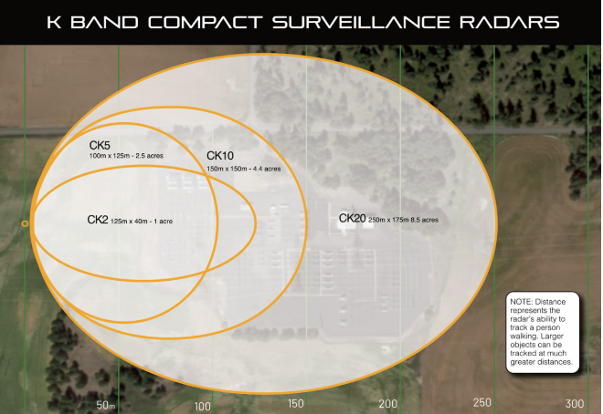
- Perfect for smaller sites such as substations in urban or suburban environments, our CK-Series radars run on the 24GHz band, which means no headaches or hassle with acquiring spectrum licenses. Combine that with the small form factor, low power draw, and quick install time, our CK-Series radars can cover your site in high heat, fog, rain, or snow.

